INFORMATION FOR FRONT OF BOOK
Additional Information
SPINE INSERT INFORMATION FOR SIDE OF BOOK
INFORMATION FOR BACK OF BOOK
Additional Information
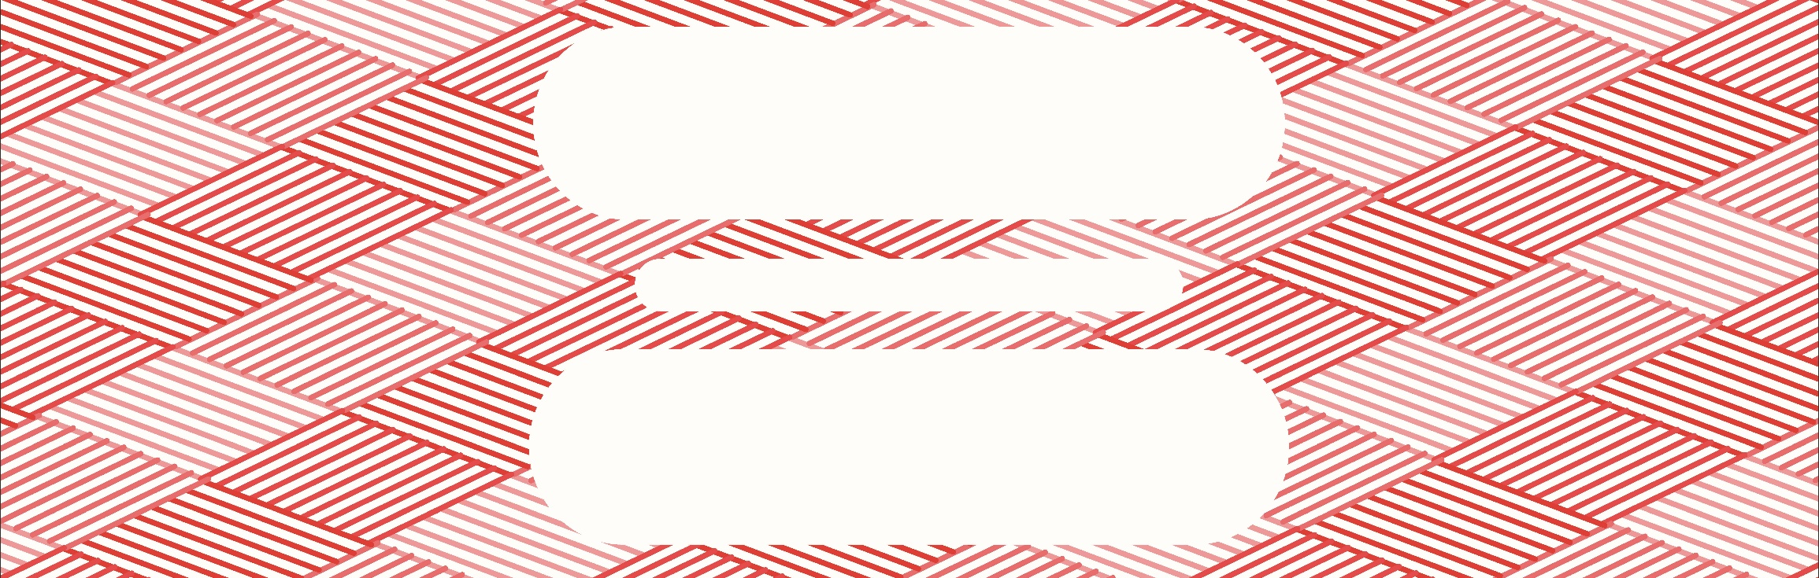

This template is for C-Line Bound Sheet Protector Book, item 33120.

Enter spine insert information and print on your own letter size (8 ½ x 11 in.) paper. Trim along lines. The overall size of the finished spine insert will be 10 ½ in. long.

To create a longer insert that will fill the entire length of the spine, please use the 33120 template designed to print on legal size (8 ½ x 14 in.) paper. It is also available in the C-Line Template Gallery.

HINT: To see where to enter your custom spine insert information, make sure the Table Gridlines are turned on.

Visit C-Line.com to see our full line of products for your home and business.

